Write here the title of your communication
Elisabetta Ranucci,ª Paolo Ferruti,ª Jenny Alongi,ª John Smith^{b}
ª Dipartimento di Chimica, Università degli Studi di Milano, via C. Golgi 19, 20133, Milano, Italy
^{b} Department of Chemistry, University of xxxxx, address xxxxxxxxxxx
elisabetta.ranucci@unimi.it
e-mail of the presenting author

Deadline for the submission: 4th June 2021

Abstract (max 500 words)

Write here your text using the following style:

- Write a single paragraph abstract using the impersonal form.
- Have no indentation and empty lines.
- Citing in the text: numbers enclosed in square brackets, e.g. [1] or [2,6] or [1-4] and placed before punctuation.
- Submit your abstract as a doc document, as an e-mail attachment to mipol2021@unimi.it
- Name the files using your last name and presentation type (oral or poster presentation): e.g.
Brown_oral.doc or Rossi_ poster.doc.
- The maximum accepted file size is 5 MB.

Synthesis of the Ru-PhenISA polymer complex

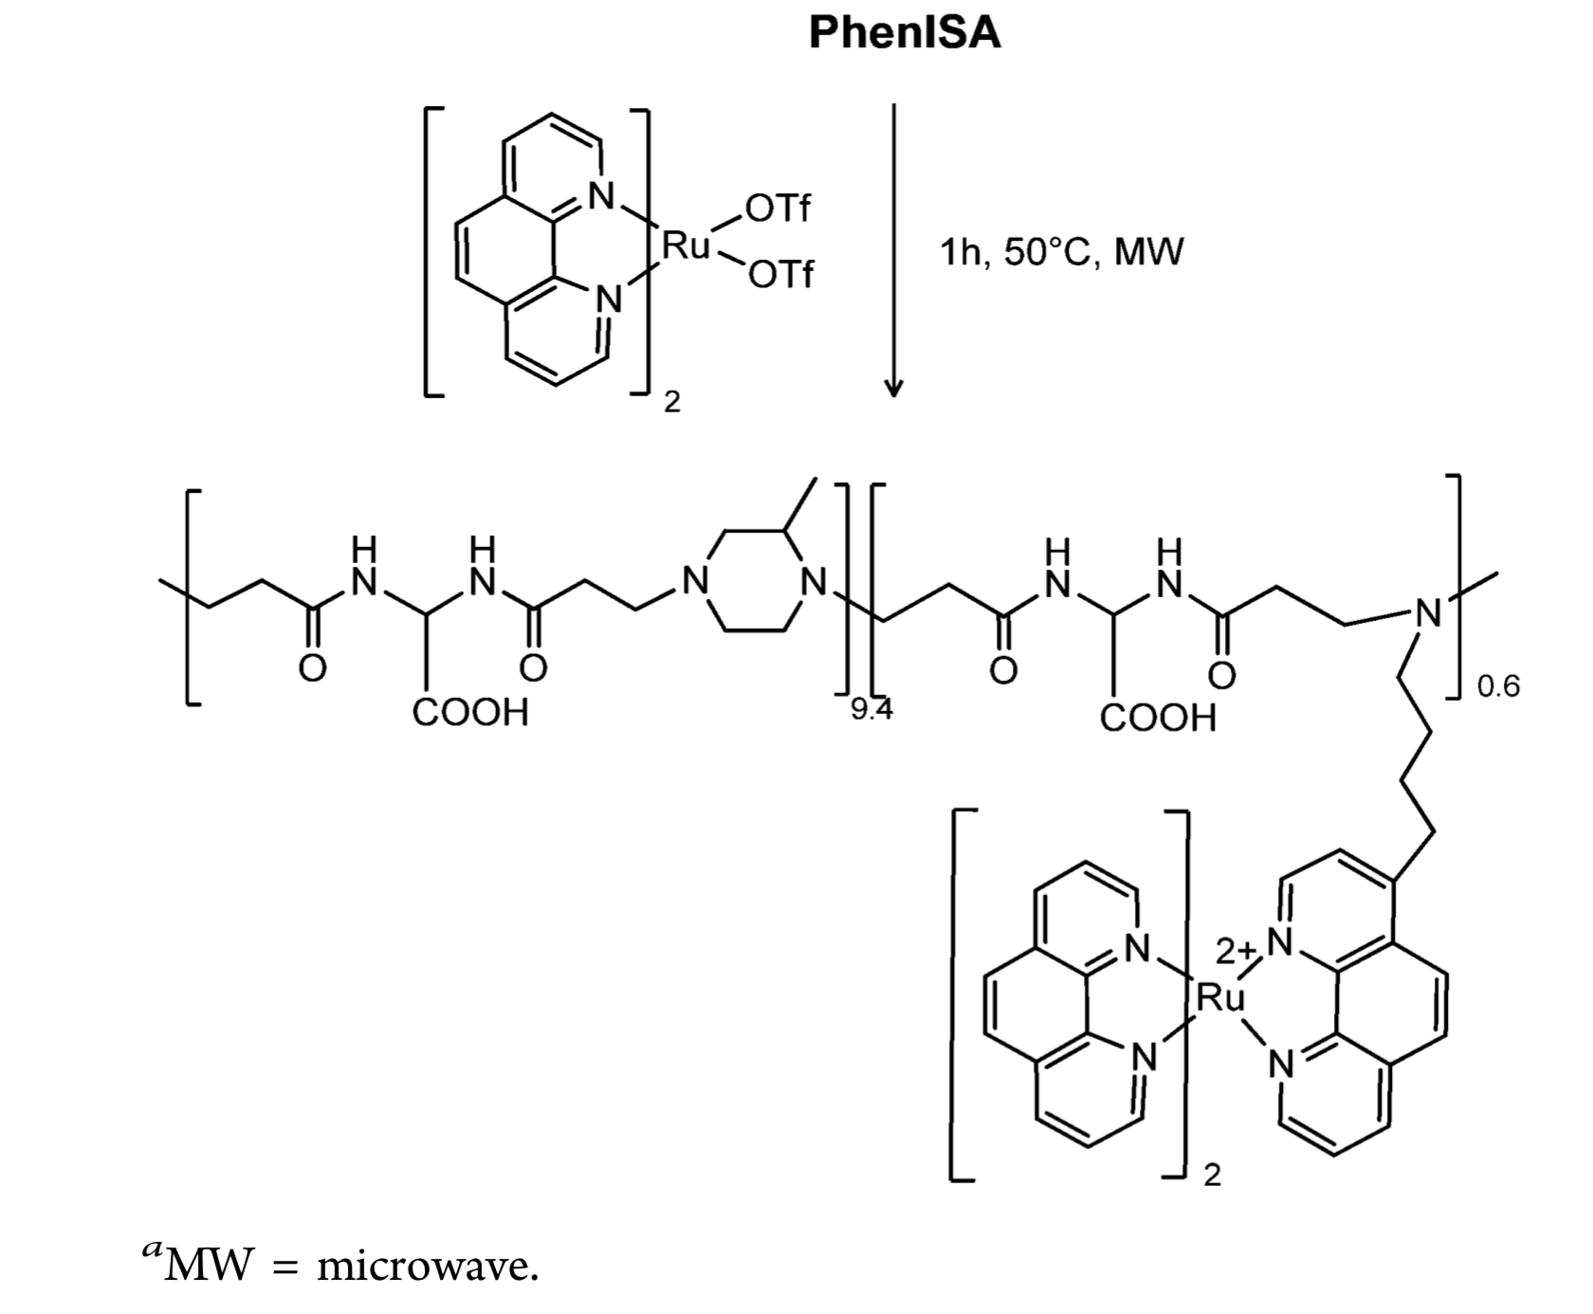

Place here your figure

References
- D. Brown, A.B. Rossi J. Name Stand. Abbrev. year, volume, first page.
- D. Brown, A.B. Rossi, Book title, Edition, year, City, State, Publisher.

Acknowledgments
All the authors acknowledge financial support…………..

